Bonus material: Multi-criteria analysis
Source: Adapted from Quillérou, Emmanuelle. 2014. ´The Economics of Land Degradation. Principles of economic analysis and valuation for sustainable management of land´. Materials prepared for the ELD’s Massive Open Online Course 2014 by the United Nations University Institute for Water, Environment and Health (UNU-INWEH)

Multi‐criteria analysis helps identify preferred scenarios without using economic valuation techniques. It can be used as an alternative to cost‐benefit analysis. It assesses options (scenarios) along several quantified or scored criteria (attributes).

- Introduction into multi-criteria analysis
Multi-criteria analysis (MCA) or multi‐criteria decision analysis (MCDA) is a semi-qualitative procedure used to compare or determine overall preferences between alternative and often conflicting options. It helps identify a preferred option in multi-disciplinary contexts without requiring agreement on the preferred option or on how to weight assessment criteria or on how to value all criteria in monetary terms.
Assessment criteria can be quantitative or qualitative (score) and can relate to social, technical, environmental, economic and financial changes. It is easy to use and has a wider scope than cost‐benefit analysis because it includes qualitative as well as quantitative data.
Multi‐criteria analysis helps identify preferred scenarios without using economic valuation techniques. It is used as an alternative to cost‐benefit analysis. It can however be seen as the ancestor of the choice modelling method because of its similar structure. It does not involve a variation of attribute and price levels but rather assesses options (scenarios) along several quantified or scored criteria (attributes). This method can thus also be used as a preliminary to environmental valuation to screen scenarios and identify a preferred scenario and its criteria to be economically valued for more formal economic assessment.
Multi-criteria analysis consists of three steps:

Step 1: Determine alternative options (scenarios) and criteria (attributes)
for appraisal.

Step 2: Measure criteria or indicators, physically, in monetary terms or by scoring
them.

Step 3: Aggregate the criteria values for each option by weighting the criteria and
select the option with the highest score.

- Description of the steps of a multi-criteria analysis

Step 1 identifies potential options (scenarios) as well as criteria or indicators to assess whether these options are socially desirable or not.
For instance, option 1 could correspond to a business‐as‐usual scenario with a reduction in productive land area of 10% per year, option 2 to actions leading to a 5% decrease in productive land area per year, and option 3 to actions leading to a 0% decrease in productive land area per year.
Examples of criteria to assess whether these options are socially beneficial are: the number of land-based jobs lost because of the reduction in productive land size, the number of jobs created by establishing alternative land‐based livelihood options (economic activities), the likelihood of floods, pollution levels, and/or recreational and cultural activities.
The general structure of a multi‐criteria analysis is represented in the following table.
Table 1: Example of a multi-criteria analysis structure

 | Option 1 | Option 2 | Option 3
Criteria c1
Criteria c2
Criteria c3
…

Step 2 involves putting a quantitative or qualitative value for each criterion and each option. Ideally, the more socially desirable the outcome, the higher the criterion value to ensure consistency of ranking across the different criteria. What really matters are the relative variations for a given criterion between options ‐ that is, the trade-off between two options for a given criterion.
For instance, option 1 is associated with losing 10 land‐based jobs, option 2 with losing 8 jobs and option 3 with losing no job. To obtain the right ordering between options, a score of 0 (=10-10) can be given to option 1, 2 (=10‐8) to option 2 and 10 to option 3 (=10-0). A similar ranking process can be applied to each criterion (table 2).
The absolute value of one criterion might affect the overall outcome if it is too different from the others. That is, if all criteria but one have their values between 1 and 10 and the last criterion has values between 100 and 200, this last criterion affects the final choice of option. A change of scale for this criterion can effectively solve this scaling problem.

Table 2: Example of multi-criteria analysis criteria

 | Option 1  Business-as-usual scenario, 10% decrease in land area per year | Option 2  5% decrease in land area per year | Option 3  0% decrease in land area per year
Criteria c1: loss of land-based jobs (score) | 0 | 2 | 10
Criteria c2: likelihood of floods | 80% | 60% | 30%
Criteria c3: loss of recreational and cultural activities | 40% | 5% | 1%

Step 3 involves determining weights for each criterion. This can be done through selected focus groups and for various stakeholders. Ideally, the final mix of stakeholders should be representative of society as a whole. Each individual stakeholder can assign weights to each criterion. The weights are aggregated to derived mean weight across all respondents for each criterion. The scores are computed for each option as the weighted sum of the criterion values (table 3). The highest value corresponds to the most socially desirable option, for either one stakeholder group or society as a whole depending on the nature of the respondent.
Table 3: Example of the general outcome of a multi-criteria analysis for selection of the most desirable option

Criteria | Weight | Option 1 | Option 2 | Option 3
Criteria c1 | w1 | c1_1 | c1_2 | c1_3
Criteria c2 | w2 | c2_1 | c2_2 | c2_3
Criteria c3 | w3 | c3_1 | c3_2 | c3_3
Criteria c4 | w4 | c4_1 | C4_2 | c4_3
VALUE (SCORE) OF OPTION |  | w1*c1_1  + w2*c2_1  + w3*c3_1  + w4*c4_1 | w1*c1_2  + w2*c2_2  + w3*c3_2  + w4*c4_2 | w1*c1_3  + w2*c2_3  + w3*c3_3  + w4*c4_3

- Methodological limitations
Multi-criteria analysis has some methodological limitations. There is a risk of double counting for overlapping objectives. Also, the method relies on expert judgement, which does not always correspond to preferences of society as a whole. The ordinal scoring of qualitative impacts is potentially too arbitrary. Where significant differences in weightings occur between particular groups, preferred scenario might drastically differ between groups. It might be difficult to derive a scenario that would be acceptable to all groups. Finally, this method is subject to small sample biases, which arise when the sample is too small to allow for extrapolation to the entire population.
- Application example- Botswana’s Kalahari rangelands
The ELD Initiative applied a multi-criteria decision analysis to identify key ecosystem service trade-offs associated with four different land uses in Botswana’s Kalahari rangelands in 2014.
Rangelands are used in a variety of ways and are the main source of rural income in Botswana. They support livestock grazing, tourism and wildlife management as well as collection of fuelwood and veld products for household use. In some parts of Botswana’s southern Kalahari, rangeland degradation has led to extensive bush encroachment, reducing access to good quality grazing and thus economic returns, and at the same time threatening the delivery of ecosystem services.
The research problem to be tackled was defined as:
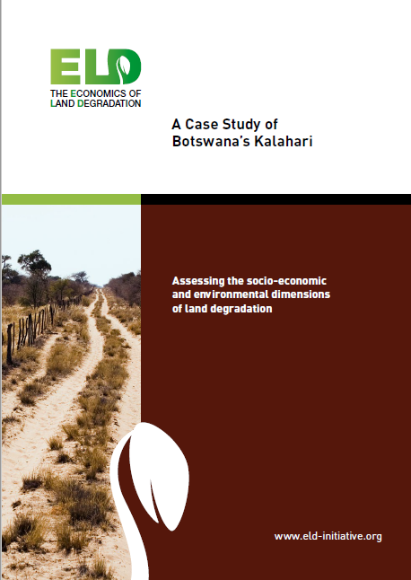
Which land uses and land management strategies are best placed to deliver specific ecosystem services in Kalahari rangelands in Botswana’s southern Kgalagadi district?
Four land uses were considered in the study:
1. Communal livestock grazing
2. Private cattle ranches
3. Private game ranches
4. Wildlife Management Areas
The performance of each land use was assessed according to its capacity to deliver ecosystem services for the year 2013. Nine criteria were identified, supported by 14 indicators (table 4), where possible drawing upon financial data or quantitative values.
Each criterion was weighted in order to reflect its relative importance for policy-making. Weighting in this case was based on a policy analysis where the main goals and priorities of national land, agriculture, development, tourism and wildlife policies were identified.
Each criterion was then scored on a homogeneous 100-point scale (where 0 = less important, 100 = most important). Scores for each criterion were multiplied by the criterion weights derived in the previous step to derive an overall weighted score (or preference score) for each land use (figure 1).
Communal livestock grazing delivered the widest range of ecosystem services, followed by Wildlife Management Areas, private cattle ranches and private game ranches. High scores achieved by communal grazing areas are mainly linked to their use for food production, with the management practices used in these areas also allowing wild food production, fuel, construction material, climate regulation and spiritual use values to be retained.

Table 4: Criteria (dark green) and indicators (light green) used to assess capacity to deliver ecosystem services- example of Botswana’s Kalahari rangelands
Food (commercial) | Net profit of meat production (US$/ha/yr);  Stocking level  (ha/Livestock Unit) | Construction material | Collection of thatching grass and poles for fencing | Climate regulation | Value of carbon sequestration (US$/ha/yr)
Food (wild) | Gathering of veld  products;  Subsistence hunting | Ground water | Value of water extracted  (US$/ha/yr) | Recreation | Revenues from CBNRM,  trophy hunting & photographic safari  (US$/ha/yr); Ecotourism potential;  Wild animal diversity
Fuel | Firewood collection | Genetic diversity | Genetic diversity between forage species;  Genetic diversity between livestock breeds | Spiritual inspiration | Presence of landscape feature or  species with spiritual value

Figure 1: Overall multi-criteria analysis scores for each land use option – example of Botswana’s Kalahari rangelands
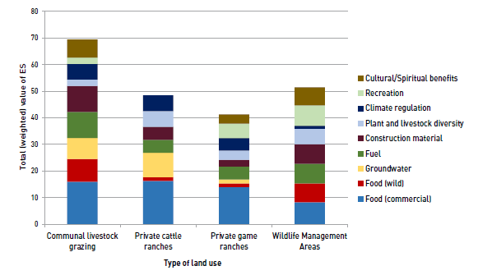
To obtain further details on this study, you can access or download the study report on ELD’s website: www.eld-initiative.org.

Community Based Natural Resource Management

